National Diabetes Prevention Program
2014 – 2015 Website Report
March 2016

Introduction

The following report showcases statistical data gathered from SiteCatalyst, CDC’s online analytics tracking system. The information captured for this report includes National Diabetes Prevention Program (National DPP) website data for 2014 and 2015. We use several common metrics in this report. Definitions and information about each of these metrics is provided as an appendix.

Executive Summary
The SiteCatalyst data for 2014 and 2015 show steady performance across the National DPP website. From 2014 to 2015, there was 15% increase in page views, 25% increase in page visits, and an 18% increase in unique visitors.

On average for 2014 and 2015, users spent 1.26 minutes on the site and visited 1.94 pages per visit (page depth). The average bounce rate of 25% for 2014 and 2015 indicated that almost all users visited more than one page per visit. The bounce rate, time spent, and page depth averages indicate that users were coming to the site for a specific purpose, finding what they need quickly, and then leaving the website almost immediately. These metrics also indicate that users did not engage with the site as a whole.

The National DPP homepage, “About the Program”, “Curriculum”, and “Prediabetes” pages were consistently the most popular pages on the website for both years. When comparing page views with the number of unique visitors in 2014 and 2015 for the “Curriculum” page, data suggests that users returned to this page more frequently than other popular pages.

From 2014 to 2015 there was a significant increase (71%) in the total number of downloads. Nearly half of all users were referred to the National DPP website from search engine websites (Google, Bing, Yahoo) and the National DPP website saw a small increase in the number of mobile users from 2014 to 2015.

Considerations for Redesigned National DPP Website

- Higher page depth and time spent on site would be indicators of increased user engagement on the redesigned National DPP website. This would mean users are viewing more pages per visit and spending more time per visit on the website. Higher engagement is an indication that users are finding value in content related to the purpose of their visit. For example, a user who visits the National DPP website to download the curriculum might visit additional pages to learn about related content.
- Given the significant increase in total number of downloads from 2014 to 2015, it would be useful to be aware of any National DPP efforts that could have promoted the website (e.g., media campaign) and resulted in the increase in total downloads from 2014 to 2015. Similar efforts should then be applied, if possible, to the redesigned National DPP website.

Page Views, Page Visits, Unique Visitors

The following graph represents the page views, page visits, and unique visitors for the National DPP website for 2014 and 2015. Page Views is the number of times a page was loaded during a specific time period. Page Visits is the number of unique visits to a page during a specific time period. If a user accesses a page multiple times during the same time period, all of those views are recorded as part of one visit. Unique Visitors is the number of unduplicated (counted only once) visitors during a specific time period.
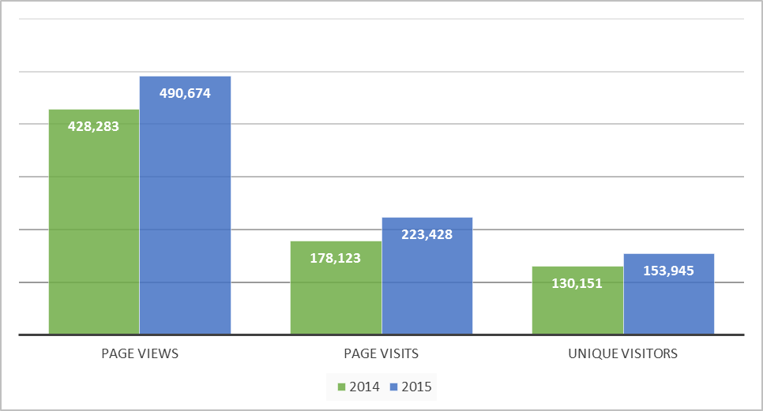

Year | Page Views | Page Visits | Unique Visitors
2014 | 428,283 | 178,123 | 130,151
2015 | 490,674 | 223,428 | 153,945
Total | 918,957 | 401,551 | 284,096

Average Page Depth (proxy for number of pages viewed per visit)

The following graph represents the average page depth on the National DPP website for 2014 and 2015. Page Depth is average number of pages that visitors view on your website during a single session. Page Depth indicates the level of user engagement with a website.

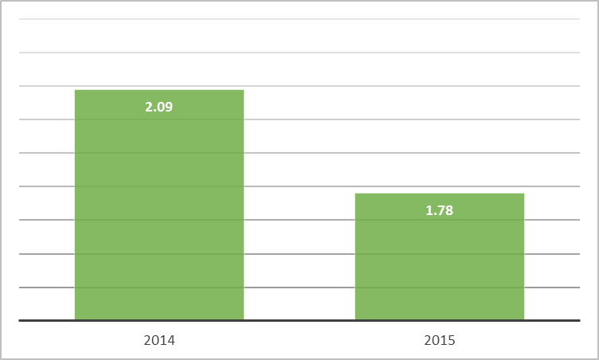

Year | Average Page Depth
2014 | 2.09
2015 | 1.78
Total Average Page Depth | 1.94

Bounce Rate

The following graph represents the bounce rate for the National DPP website for 2014 and 2015. Bounce Rate is the percentage of visits that go only one page before exiting a website. Bounce Rate indicates if users are visiting other pages on a website or leaving after only visiting one page.

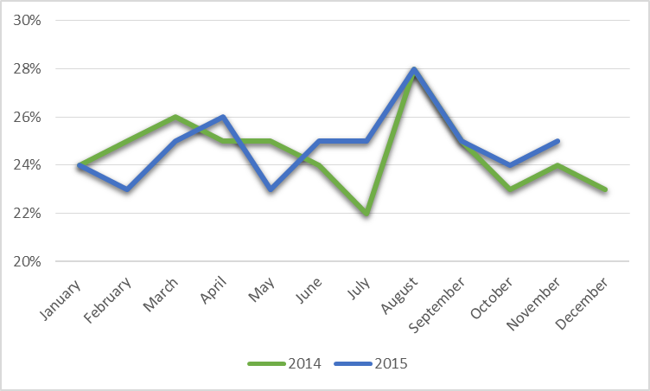

Date | Bounce Rate | Date | Bounce Rate
January 2014 | 24% | January 2015 | 24%
February 2014 | 25% | February 2015 | 23%
March 2014 | 26% | March 2015 | 25%
April 2014 | 25% | April 2015 | 26%
May 2014 | 25% | May 2015 | 23%
June 2014 | 24% | June 2015 | 25%
July 2014 | 22% | July 2015 | 25%
August 2014 | 28% | August 2015 | 28%
September 2014 | 25% | September 2015 | 25%
October 2014 | 23% | October 2015 | 24%
November 2014 | 24% | November 2015 | 25%
December 2014 | 23% | December 2015 | --
Average Bounce Rate 2014 | 25% | Average Bounce Rate 2015 | 25%

Time Spent on Site

The following graph represents the time spent on the National DPP website for 2014 and 2015. Time Spent on Site indicates the amount of time (in minutes) users spend on a website.

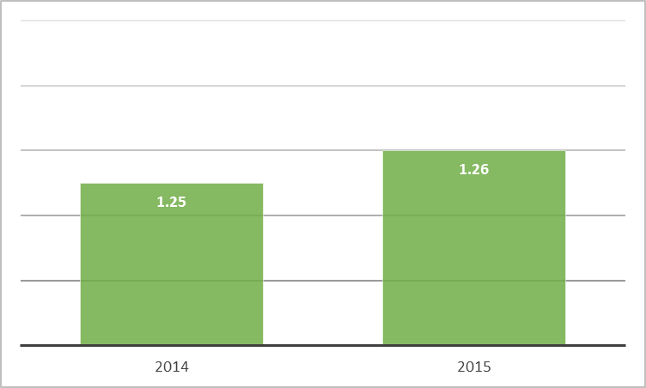

Year | Time Spent on Site (in minutes)
2014 | 1.25
2015 | 1.26
Total Average Time on Site | 1.26

Geography of Visitors

The following chart represents the top 10 states from which visitors came to the National DPP website for 2014 through 2015.
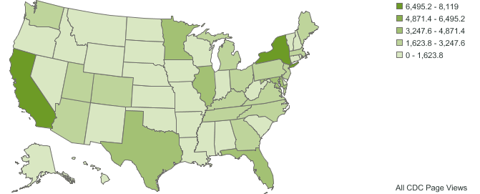

US State | Page Views
California | 8,119
New York | 7,350
Texas | 4,112
Florida | 3,883
Minnesota | 3,550
Illinois | 3,300
Maryland | 3,275
Pennsylvania | 3,240
Michigan | 3,230
Virginia | 2,915

Most Popular Pages

The following charts represent the most popular pages, by page views, for the National DPP website for 2014 and 2015.

Most Popular Pages – 2014 | Page Views
CDC - National Diabetes Prevention Program - Diabetes DDT | 103,782 | 24.2%
CDC - About the Program - National Diabetes Prevention Program - Diabetes DDT | 50,377 | 11.8%
CDC - Curriculum - Diabetes Prevention Recognition Program – Diabetes DDT | 41,559 | 9.7%
CDC - Prediabetes - National Diabetes Prevention Program - Diabetes DDT | 38,078 | 8.9%
CDC - Registry - Diabetes Prevention Recognition Program – Diabetes DDT | 35,617 | 8.3%
CDC - Diabetes Prevention Recognition Program - Diabetes DDT | 20,350 | 4.8%
CDC - Lifestyle Coach Training - National Diabetes Prevention Program - Diabetes DDT | 14,316 | 3.3%
CDC - Prediabetes Facts - National Diabetes Prevention Program - Diabetes DDT | 11,892 | 2.8%
CDC - Resources - National Diabetes Prevention Program - Diabetes DDT | 11,746 | 2.7%
CDC - Lifestyle Coach and Master Training - Diabetes DDT | 10,471 | 2.4%

Most Popular Pages – 2015 | Page Views
CDC - National Diabetes Prevention Program - Diabetes DDT | 134,611 | 27.4%
CDC - Prediabetes - National Diabetes Prevention Program - Diabetes DDT | 77,709 | 15.8%
CDC - Curriculum - Diabetes Prevention Recognition Program – Diabetes DDT | 65,221 | 13.3%
CDC - About the Program - National Diabetes Prevention Program - Diabetes DDT | 48,720 | 9.9%
CDC - Diabetes Prevention Recognition Program - Diabetes DDT | 39,218 | 8.0%
CDC - Lifestyle Coach and Master Training - National Diabetes Prevention Program - Diabetes DDT | 27,026 | 5.5%
CDC - Standards - Diabetes Prevention Recognition Program – Diabetes DDT | 15,751 | 3.2%
CDC - Resources - National Diabetes Prevention Program - Diabetes DDT | 15,267 | 3.1%
CDC - NDPP Video - National Diabetes Prevention Program - Diabetes DDT | 9,003 | 1.8%
CDC - About - Diabetes Prevention Recognition Program – Diabetes DDT | 7,810 | 1.6%

Most Popular Pages (cont.)

The following charts represent the most popular pages, by unique visitors, for the National DPP website for 2014 and 2015.

Most Popular Pages – 2014 | Unique Visitors
CDC - National Diabetes Prevention Program - Diabetes DDT | 61,528 | 47.3%
CDC - About the Program - National Diabetes Prevention Program - Diabetes DDT | 29,626 | 22.8%
CDC - Prediabetes - National Diabetes Prevention Program - Diabetes DDT | 28,429 | 21.8%
CDC - Registry - Diabetes Prevention Recognition Program – Diabetes DDT | 21,375 | 16.4%
CDC - Curriculum - Diabetes Prevention Recognition Program – Diabetes DDT | 19,087 | 14.7%
CDC - Diabetes Prevention Recognition Program - Diabetes DDT | 11,810 | 9.1%
CDC - Prediabetes Facts - National Diabetes Prevention Program - Diabetes DDT | 10,045 | 7.7%
CDC - Resources - National Diabetes Prevention Program - Diabetes DDT | 8,017 | 6.2%
CDC - Lifestyle Coach Training - National Diabetes Prevention Program - Diabetes DDT | 7,794 | 6.0%
CDC - Standards - National Diabetes Prevention Program – Diabetes DDT | 6,520 | 5.0%

Most Popular Pages – 2015 | Unique Visitors
CDC - National Diabetes Prevention Program - Diabetes DDT | 72,957 | 47.2%
CDC - Prediabetes - National Diabetes Prevention Program - Diabetes DDT | 56,693 | 36.8%
CDC - Curriculum - Diabetes Prevention Recognition Program – Diabetes DDT | 29,348 | 19.1%
CDC - About the Program - National Diabetes Prevention Program - Diabetes DDT | 28,913 | 18.8%
CDC - Diabetes Prevention Recognition Program - Diabetes DDT | 20,854 | 13.5%
CDC - Lifestyle Coach and Master Training - National Diabetes Prevention Program - Diabetes DDT | 17,030 | 11.1%
CDC - Standards - Diabetes Prevention Recognition Program – Diabetes DDT | 10,005 | 6.5%
CDC - Resources - National Diabetes Prevention Program - Diabetes DDT | 9,630 | 6.3%
CDC - NDPP Video - National Diabetes Prevention Program - Diabetes DDT | 6,430 | 4.2%
CDC - About - Diabetes Prevention Recognition Program – Diabetes DDT | 5,257 | 3.4%

Referring Domains

The following charts represent the top ten referring domains of the National DPP website for 2014 and 2015.

Referring Domains – 2014 | Instances
google.com | 67,715 | 41.7%
Typed/Bookmarked | 40,069 | 24.6%
bing.com | 9,891 | 6.1%
nih.gov | 3,621 | 2.2%
diabetes.org | 3,389 | 2.1%
yahoo.com | 2,783 | 1.7%
govdelivery.com | 1,902 | 1.2%
diabeteseducator.org | 1,363 | 0.8%
google.co.in | 1,274 | 0.8%
google.co.uk | 1,237 | 0.8%

Referring Domains – 2015 | Instances
google.com | 78,958 | 38.0%
Typed/Bookmarked | 58,806 | 28.3%
bing.com | 12,403 | 6.0%
yahoo.com | 6,539 | 3.1%
healthline.com | 5,560 | 2.7%
diabetes.org | 4,516 | 2.2%
aol.com | 2,104 | 1.0%
nih.gov | 2,055 | 1.0%
cbslocal.com | 1,855 | 0.9%
google.co.uk | 1,798 | 0.9%

Top Level Domains

The following table shows the top level domains for visitors to the National DPP website for 2014 and 2015. Top Level Domains are the extension (.com, .edu, .gov, etc) at the end of a web address for users of the National DPP website. This indicates the domain from which visitors of the DCH website are originating.

Top Level Domains 2014 | Daily Unique Visitors
Network (mostly U.S.) | 12,502 | 40.3%
Commercial (mostly U.S.) | 6,645 | 21.4%
U.S. Educational Institution | 2,602 | 8.4%
Organization (mostly U.S.) | 2,300 | 7.4%
U.S. Government | 1,147 | 3.7%

Top Level Domains 2015 | Daily Unique Visitors
Network (mostly U.S.) | 15,537 | 38.5%
Commercial (mostly U.S.) | 8,927 | 22.1%
U.S. Educational Institution | 3,547 | 8.8%
Organization (mostly U.S.) | 2,892 | 7.2%
U.S. Government | 1,803 | 4.5%

Downloads

The following chart represents the most popular downloads from the National DPP website for 2014 and 2015.

Downloads 2014 | Instances
http://www.cdc.gov/diabetes/prevention/pdf/dprp_standards_09-02-2011.pdf | 5,971
http://www.cdc.gov/diabetes/prevention/pdf/prediabetestest.pdf | 5,606
http://www.cdc.gov/diabetes/prevention/pdf/curriculum.pdf | 3,856
http://www.cdc.gov/diabetes/prevention/pdf/curriculum_session1.pdf | 3,082
http://www.cdc.gov/diabetes/prevention/pdf/curriculum_cover.pdf | 2,701
http://www.cdc.gov/diabetes/prevention/pdf/curriculum_session2.pdf | 2,414
http://www.cdc.gov/diabetes/prevention/pdf/handouts.pdf | 2,233
http://www.cdc.gov/diabetes/prevention/pdf/handout_session1.pdf | 2,160
http://www.cdc.gov/diabetes/prevention/pdf/handout_session2.pdf | 1,993
http://www.cdc.gov/diabetes/prevention/pdf/curriculum_intro.pdf | 1,820

Downloads 2015 | Instances
http://www.cdc.gov/diabetes/prevention/pdf/prediabetestest.pdf | 10,412
http://www.cdc.gov/diabetes/prevention/pdf/dprp-standards.pdf | 9,543
http://www.cdc.gov/diabetes/prevention/pdf/NDPP_Infographic.pdf | 6,745
http://www.cdc.gov/diabetes/prevention/pdf/curriculum.pdf | 4,988
http://www.cdc.gov/diabetes/prevention/pdf/curriculum_session1.pdf | 4,754
http://www.cdc.gov/diabetes/prevention/pdf/STAT_toolkit.pdf | 4,191
http://www.cdc.gov/diabetes/prevention/pdf/curriculum_terms.pdf | 4,161
http://www.cdc.gov/diabetes/prevention/pdf/curriculum_cover.pdf | 4,016
http://www.cdc.gov/diabetes/prevention/pdf/curriculum_session2.pdf | 3,574
http://www.cdc.gov/diabetes/prevention/pdf/capacity-assessment.pdf | 3,189

Device Type

The following graphs show the type of device visitors used to access the National DPP website for 2014 and 2015.

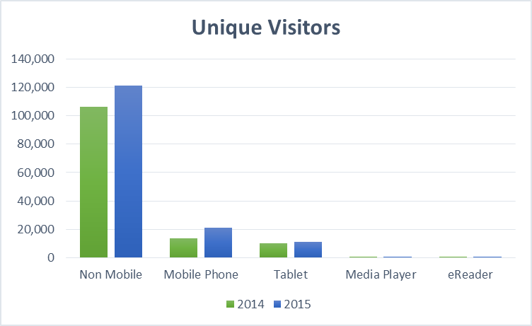
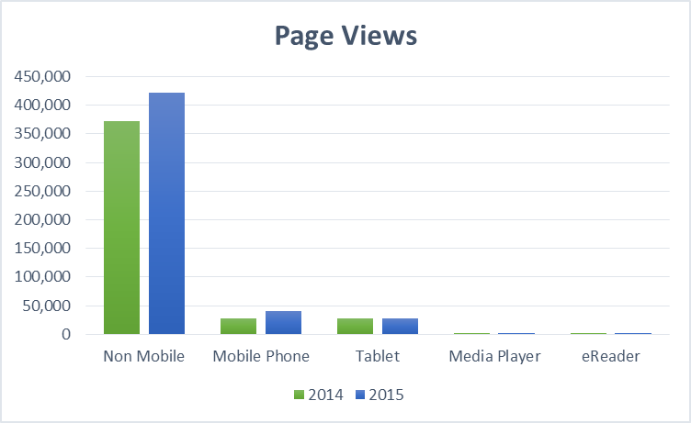

Device Type | 2014  Page Views |  | 2014  Unique Visitors |  | 2015  Page Views |  | 2015  Unique Visitors
Non Mobile Phone | 372,661 | 87.0% | 106,075 | 81.5% | 422,087 | 86.0% | 121,443 | 78.9%
Mobile Phone | 27,370 | 6.4% | 13,795 | 10.6% | 41,222 | 8.4% | 21,257 | 13.8%
Tablet | 28,031 | 6.5% | 10,147 | 7.8% | 27,196 | 5.5% | 11,149 | 7.2%
Media Player | 209 | 0.0% | 132 | 0.1% | 150 | 0.0% | 88 | 0.1%
eReader | 6 | 0.0% | 3 | 0.0% | 10 | 0.0% | 7 | 0.0%
Total | 428,277 |  | 130,152 |  | 490,665 |  | 153,944

Appendix: Omniture Metric Definitions

The metrics included in this report are described in the chart below.
Metric | Definition | Implication
Page Views | Number of times a page was loaded during a specific time period. | Proxy for size of an audience (will be higher than visits or unique visitors).
Page Visits | Number of unique visits to a page during a specific time period. If a user accesses a page multiple times during the same 30-minute time period, all of those views are recorded as part of one visit. | Indicates audience size (will be lower than page views and higher than visits).
Unique Visitors | Number of unduplicated (counted only once) visitors during a specific time period. | Measures the size of an audience.
Average Page Depth | Average number of pages viewed prior to viewing the relevant page during a visit to a website. Repeated views of a single page are counted separately based on the order in which the user accessed the page. | Indicates engagement with the section of the website.
Bounce Rate | Bounce rate is the percentage of visits that go only one page before exiting a site. | Indicates if users are visiting other pages of a website or leaving after only visiting the homepage.
Time Spent on Site | The amount of time (in minutes) users spend on a site across all visits. | Indicates level of interest or involvement a visitor has with a website.
Visitor Geography | The geographic location from which users access a website. | Indicates from which specific states and cities visitors access a website.
Most Popular Pages | A count of the number of times each page within a section was viewed during the relevant time period. | Indicates which specific pages within a website receive the most page views.
Referring Domains | The address of the Web site that the user visited immediately prior to accessing the page. | Indicates how users are finding a particular Web site.
Top Level Domains | The domain extension at the end of a web address for users of the DCH website. | Indicates from where a visitor of the DCH website originates. For example, commercial domains (.com), non-profit (.org), or government (.gov).
Downloads | A count of the number of times a file is downloaded. | Indicates which files within a website that users are downloading most frequently.
Device Type | The type of device visitors used to access a website. | Indicates what physical device visitors are using to access a website.

